** README document for Ubuntu 16.04 versions **
INSTALLATION OF QUARTUS AND SUPPORTING SOFTWARES
Note: The operating system is expected to be Ubuntu 16.04. Other OS issues, if any, might not get resolved in our scope. In that case, use of lab machines is recommended.
=======================================================================

A) Check for Ubuntu updates:

Type the following command in the terminal
- sudo apt-get update

** Only for 64-bit Ubuntu, following libraries are required on the machine. So run these (additional) commands in the terminal

-----------------------------------------------------------------------------------------------------------------------
sudo apt-get install libxft2
sudo apt-get install libxft2:i386
sudo apt-get install libncurses5
sudo apt-get install libncurses5:i386
sudo apt-get install libxtst6
sudo apt-get install libsm6:i386
sudo apt-get install libxtst6:i386
------------------------------------------------------------------------------------------------------------------------
B) Altera Quartus II:- is a programmable logic device design software from Altera. Quartus II enables analysis and synthesis of HDL designs, which enables the developer to compile their designs, perform timing analysis, examine RTL diagrams, simulate a design's reaction to different stimuli, and configure the target device with the programmer. Quartus includes an implementation of VHDL and Verilog for hardware description, visual editing of logic circuits, and vector waveform simulation).(Source: https://en.wikipedia.org/wiki/Altera_Quartus)

* Steps to install Quartus-II Lite Linux(Version 16.0):

1) Go to this link:
http://fpgasoftware.intel.com/?edition=lite&language=en_US

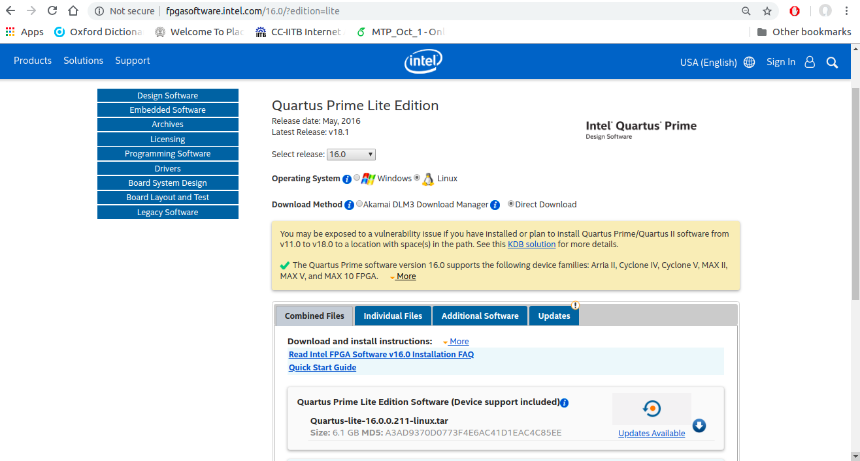
2) Download ‘Quartus-lite-16.0.0.211-linux.tar’ as shown in image below.
Click here to download

Create an ‘individual’ account while downloading the Quartus.

3) Go to the location, where the file is downloaded.

4) Extract or uncompress by “right click” on the file and use “Extract Here” option
or run the command:
sudo tar -xvf Quartus-lite-16.0.0.211-linux.tar

5) Then go to the uncompressed folder “Quartus-lite-16.0.0.211-linux” by using
cd Quartus-lite-16.0.0.211-linux

6) Then run the command: ./setup.sh

Note: If some permission issue occurs, then execute the following commands (
ls -la
(list from this folder all the files along with their permissions)
chmod +x setup.sh
(changing the permission of setup.sh file to executable mode by ‘x’)
chmod +x components/*
Then run the command:
./setup.sh

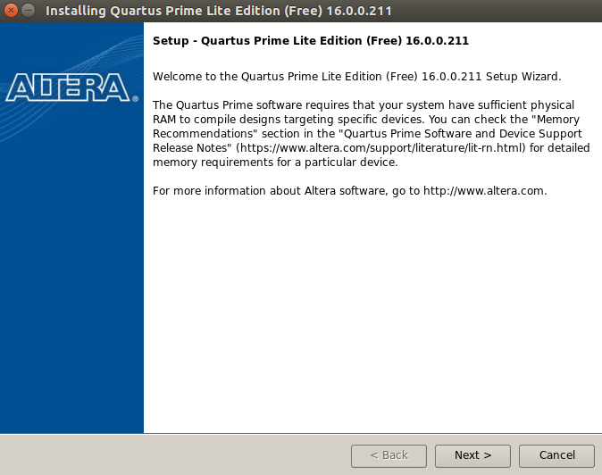
Now the installation starts:

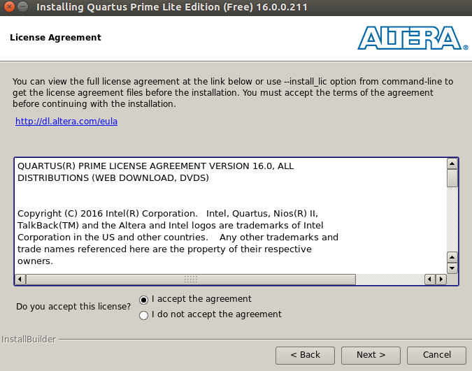
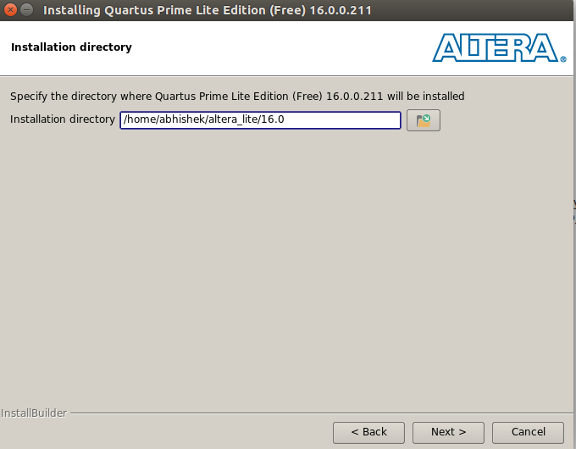
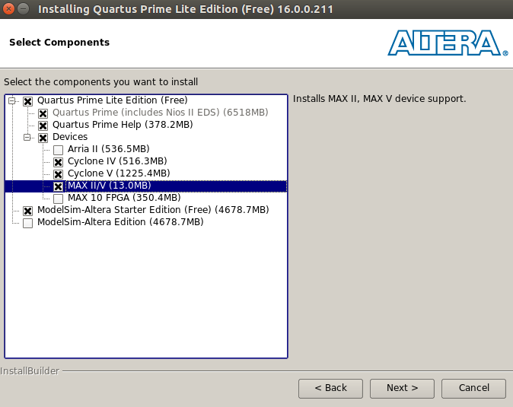
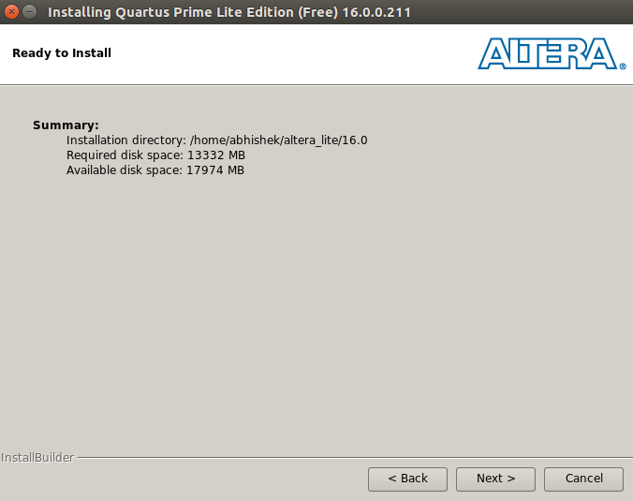
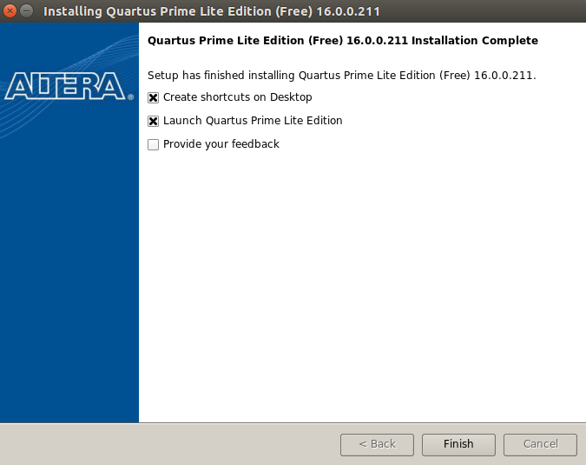

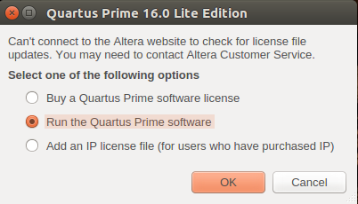

You are done with the Quartus-II Installation.

C) Modelsim:

1. After installation go to, cd <Quartus_installtion_PATH>altera_lite/16.0/modelsim_ase/bin

2. Run the command ./vsim.

Additional settings for Ubuntu 16.04 only:
If you are getting the error (“Could not find ../linux_rh60”) for ModelSim on Ubuntu 16.04,
use the following corrections.
cd /<Quartus_installtion_PATH>/altera/16.0/modelsim_ase/bin
sudo gedit vsim
(Note: Keep a original copy of a vsim file as a backup. If you make any mistake in the editing, then it will be difficult for you to find out the errors)
- change mode=${MTI_VCO_MODE:-""} to mode=${MTI_VCO_MODE:-"32"}

- change vco="linux_rh60" to vco="linux"
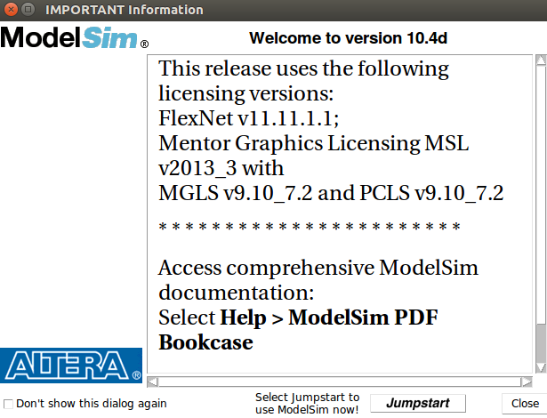

ModelSim Graphical environment will be available to test your simulation results

If graphical interface doesn’t show up, install following dependencies:
- sudo apt-get install libxft2:i386
- sudo apt-get install libxrender1:i386 libxtst6:i386 libxi6:i386
- sudo dpkg --add-architecture i386
- sudo apt-get update
- sudo apt-get install build-essential

- sudo apt-get install gcc-multilib g++-multilib lib32z1 lib32stdc++6 lib32gcc1 expat:i386 fontconfig:i386 libfreetype6:i386 libexpat1:i386 libc6:i386 libgtk-3-0:i386 libcanberra0:i386 libpng12-0:i386 libice6:i386 libsm6:i386 libncurses5:i386 zlib1g:i386 libx11-6:i386 libxau6:i386 libxdmcp6:i386 libxext6:i386 libxft2:i386 libxrender1:i386 libxt6:i386 libxtst6:i386

Testing of Modelsim through Quartus-II (Optional)
- Open the .qpf project file in the Quatus-II environment (This will include all the related files)
- Open the VDHL files of this project
- Compile the project files
- Then, run RTL Simulation in the Tools menu (This will invoke the modelsim window).

D) To install UrJTAG (Software tool to download bit file from PC to CPLD board)

1) sudo apt-get remove urjtag
or sudo apt-get remove urjtag:i386 (to remove other versions of Urjtag, if any)
2) Unzip the file ‘urjtag.zip’.
3) Install the package by typing (do not copy the name of the file) following in the terminal:
sudo apt install /<PATH of Urjtag file>/urjtag_0.10+r2007-1_i386.deb
4) Then follow the steps to add the "device information file" (“altera.tar.gz” is available inside the the folder ‘urjtag’ extracted earlier.)
- sudo cp -r /<PATH>/altera.tar.gz /usr/share/urjtag (Mention correct location of "altera.tar.gz" file)
- cd /usr/share/urjtag
- sudo tar -zxvf altera.tar.gz
- sudo chmod -R 755 altera

Note: Since higher versions of urjtag has compatibility issues, we will stop the update of the urjtag by locking it to the currently installed version.

1) Open the application ‘Synaptic Package Manager’. (install if it’s not on your PC)
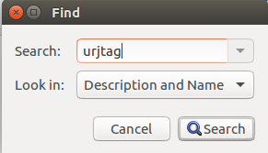
2) Search for ‘urjtag’

3) Select ‘urjtag:i386’.
4) Go to Packages->Lock Version.

Now you have successfully locked the installed version of urjtag !

Lab Work: To check the connection with Krypton CPLD and to download “bit file” to the board:
First, connect the Krypton board to your PC.
Type the following commands in the terminal
1) sudo jtag

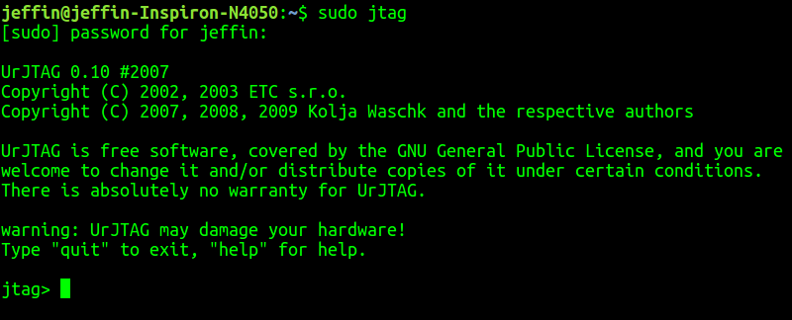

2) cable ft2232 vid=0x0403 pid=0x6010
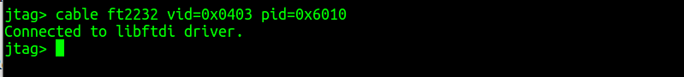

3) detect

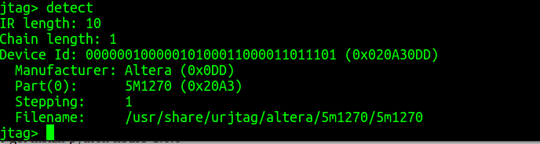
4) svf <location of the svf file/filename.svf> progress
(to download the bit file to CPLD board)

E) Installation of pyusb (Required for Scan Chain) [Required for Scan Chain]

1) Install Python and other dependencies:
sudo apt-get install python libusb-1.0.0

2) Locate the zip file ‘pyusb-master.zip’, and unzip it.

5) setup.py is available in the extracted folder

- cd <path of setup.py>
- sudo python setup.py install

6) cd <path of scan.py> (scan.py is available in scan chain supporting materials)

After the installation run the scan.py script with the following command.
For Tiva-C : sudo python scan.py input file output file tiva
